Sample size
2024-05-09
Sample size calculations for “two treatment methods in chronic kidney disease patients”
The minimum sample size with Assuming the 30% reduction in IS levels with treatment.1 administration is 48 in each group with adding 20% dropout to get 60 patient in each group with an observed effect size of f = 0.3, a power of 90%, and a significance level of 5%. Sample size estimation was done using R software 4.4.0 (1).

library(pwr)
paov1<-pwr.anova.test(k=3, f=0.3,sig.level = 0.05, power = 0.90)
plot(paov1)

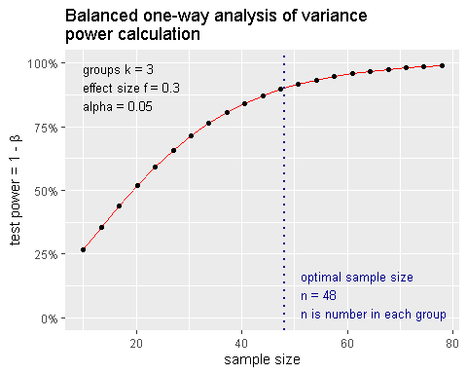

The minimum sample size assuming the 30% reduction in IS levels using treatment.2 is 37 in each group with adding 10% dropout to get with 41 patient in each group with an observed effect size of f = 0.3, a power of 80%, and a significance level of 5%. Sample size estimation was done using R software4.4.0.

paov2<-pwr.anova.test(k=3, f=0.3,sig.level = 0.05, power = 0.80)
plot(paov2)
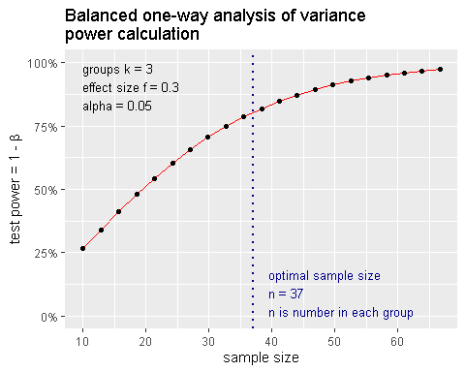

References:

